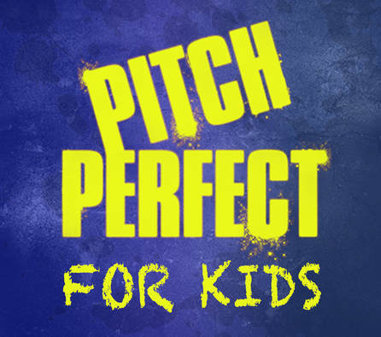
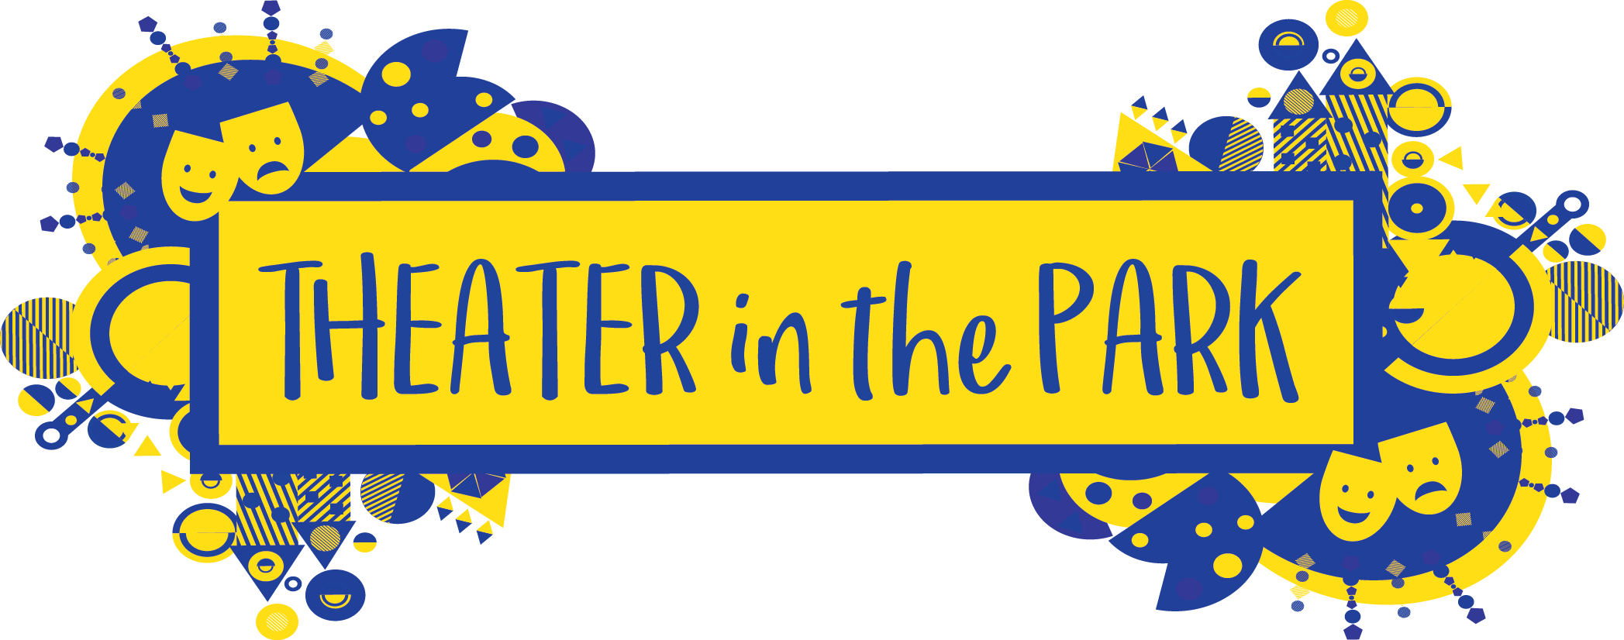

Registration Form for Pitch Perfect for Kids – Ages 8-14

Child’s Name: ________________________________________ Age: __________________

Grade: ________________ Gender: _________________

Parent or Guardian Info

(1) Name: _______________________________ Relationship to Child: ___________________

(2) Name: _______________________________ Relationship to Child: ___________________

(1) Address: ____________________________ (2) Address: ____________________________

____________________________ ____________________________

(1) Email: _________________________________ Phone/cell #: _________________________

(2) Email: _________________________________ Phone/cell #: _________________________

Does this child have any allergies, medical concerns or learning/behaviors that we should be aware of?
(All comments will be strictly confidential) (You may use back of form if space is needed)

______________________________________________________________________________

General Information and Policies
• Theater in the Park Workshop is a 9 week session Monday Evening from February 11th – April 8th , 2019 6:30 – 8:00 p.m.
• Attendance at each of the classes is extremely important.
• The performance is on Monday April 8th at Union Jacks in Annapolis.
• Tuition payment of $285 must accompany this registration form to reserve a spot in the workshop. Tuition covers the registration, instruction, script, music CD.
• Tuition is non-refundable.

Payment (Circle One) Check or Cash or Online Payment (www.theaterinthepark.net)

Name on check: ___________________________________ Check #: _____________ Date: __________
Payable to Theater in the Park

Parent or Guardian Signature:

_____________________________ _________________________________ ________________________
Print Name Sign Name Date

Mail completed form to:
Severna Park Community Center: Theater in the Park, 623 Baltimore Annapolis Blvd, Severna Park MD 21146

