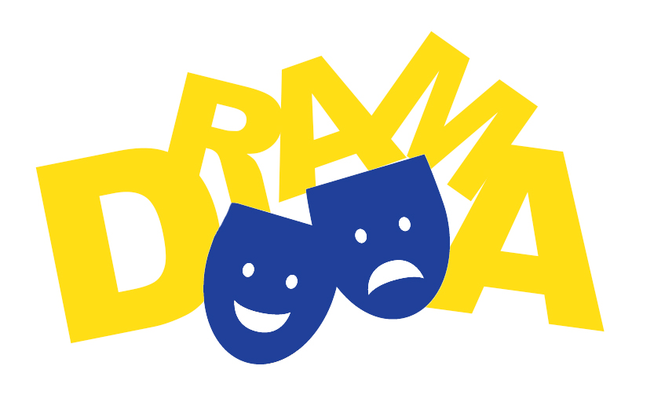
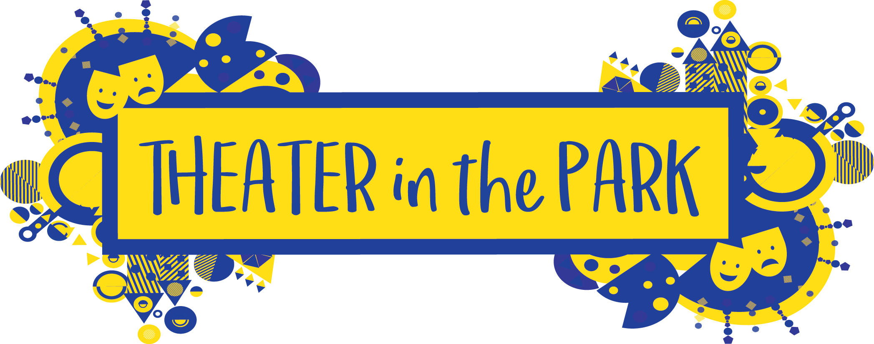

Registration Form for Dramatic Arts Workshop for Kids – Ages 8-14

Child’s Name: ________________________________________ Age: __________________

Grade: ________________ Gender: _________________

Parent or Guardian Info

(1) Name: _______________________________ Relationship to Child: ___________________

(2) Name: _______________________________ Relationship to Child: ___________________

(1) Address: ____________________________ (2) Address: ____________________________

____________________________ ____________________________

(1) Email: _________________________________ Phone/cell #: _________________________

(2) Email: _________________________________ Phone/cell #: _________________________

Does this child have any allergies, medical concerns or learning/behaviors that we should be aware of?
(All comments will be strictly confidential) (You may use back of form if space is needed)

______________________________________________________________________________

General Information and Policies
• Theater in the Park Workshop is a 12 week session Thursday Evening from September 6th — November 29th, 2018 6:30 – 8:00 p.m.
• Attendance at each of the classes is extremely important.
• The performance is on Friday November 20th in Holy Grounds.
• Tuition payment of $285 must accompany this registration form to reserve a spot in the workshop. Tuition covers the registration, instruction, and script. Tuition does not cover the cost of costumes. Parents work together with directors to find affordable costumes and props for the students.
• Tuition is non-refundable.

Payment (Circle One) Check or Cash or Online Payment (www.theaterinthepark.net)

Name on check: ___________________________________ Check #: _____________ Date: __________
Payable to Theater in the Park

Parent or Guardian Signature:

_____________________________ _________________________________ ________________________
Print Name Sign Name Date

Mail completed form to:
Severna Park Community Center: Theater in the Park, 623 Baltimore Annapolis Blvd, Severna Park MD 21146

